Bilaga 3

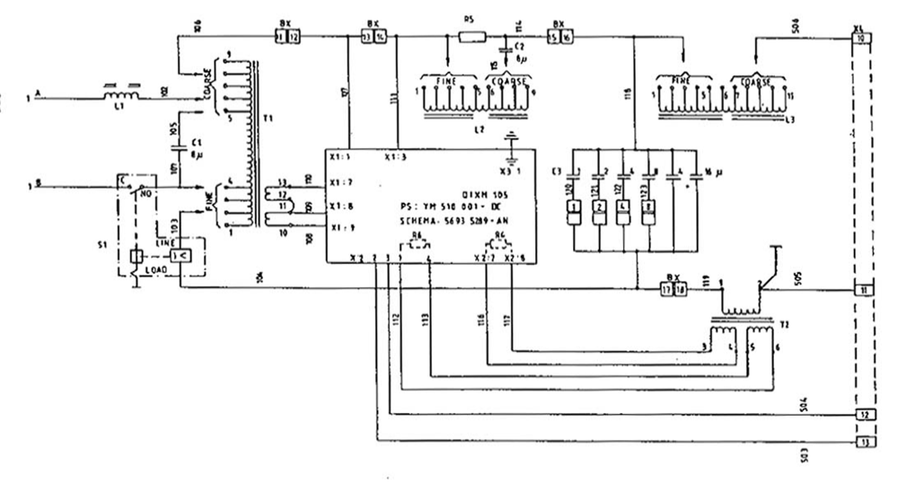
Kretsschema, magnetiseringsdon QIXM 108/109

